Eileen Hewer Community Fund
Application Process - Frequently Asked Questions

Q1. What is the Eileen Hewer Community Fund?
Bournville Village Trust (BVT) are required by the long term stewardship agreement for Lawley to provide community support and development opportunities. This is in line with BVT’s community aims and values as a charitable trust. The Community Fund itself was created in 2017 by the Lawley Management Committee to honour Eileen Hewer, who sadly passed away in 2016. Eileen was a Lawley resident who worked tirelessly to make sure residents’ voices were heard, through her role as chair of Lawley Village Community Association and as a member of the Lawley Management Committee. The Eileen Hewer Community Fund awards grants yearly to groups working for the benefit of the community and Lawley residents. The community grant is funded by the BVT charge payer’s contributions.
Q2. How do I complete an application?
The application form asks for details of the project, organisation and the anticipated benefits to Lawley residents and the wider community. There is a section on costings where details of the spending are required. Groups or organisations seeking a grant must complete the application form and email it to the address lawleystewardship@bvt.org.uk. Applications from groups and organisations are reviewed by the Lawley Village Community Association and are voted on by members, at which there are always Lawley residents present. Applications should ideally have several quotes to show value for money and groups/organisations must also provide receipts on request. A grant cannot be paid to individuals directly. The application decision will be communicated with you within 14 days of the meeting. The grant must be used for the stated purpose on the application and we require you to complete an evaluation form for your completed project.
Q3. Is my group/project eligible for a grant?
If you run or belong to a community group or organisation that are based in or benefit the Lawley community, you could apply for a grant of up to £2,000 yearly. In addition, grants can be given to projects that enhance the environment or provide facilities for Lawley residents to use. You will need to be able to provide receipts. This fund cannot be paid to individuals, however there are circumstances where equipment/supplies can be purchased by BVT through the grant. For example, if it is for a community project being delivered by an individual. Please contact us for guidance if you are unsure.
Q4. How do I make my application successful?
To be successful in your application it is suggested to include: numbers/percentages of Lawley residents who will benefit/participate, obtain more than one quote to demonstrate good value for money, include details of any match funding or other funding streams for the project and state any community collaborations the project may lead to (i.e. if there are other groups across the community who may benefit from this project outside of your organisation). We will gladly work with you during the application procedure to support your grant bid.
Q5. What have previous grants paid for?
Previous grants have paid for kits for youth football teams, new play equipment for nurseries, supporting the training of a professional coach for Lawley Running Club, buying new event equipment for a school, providing storage and tents for Lawley Scout Group, paying for Lawley Walkers group tops, supported the Lawley Village Youth Group, supported community events/celebrations and contributions to charitable causes.
Q6. What are BVT’s main aims and values?
BVT’s mission is to create and sustain communities where people can thrive. Please see Figure 1 for details of our aims and Figure 2 for our values. Please consider these themes when writing your application.

Figure 1 – BVT Company Aims
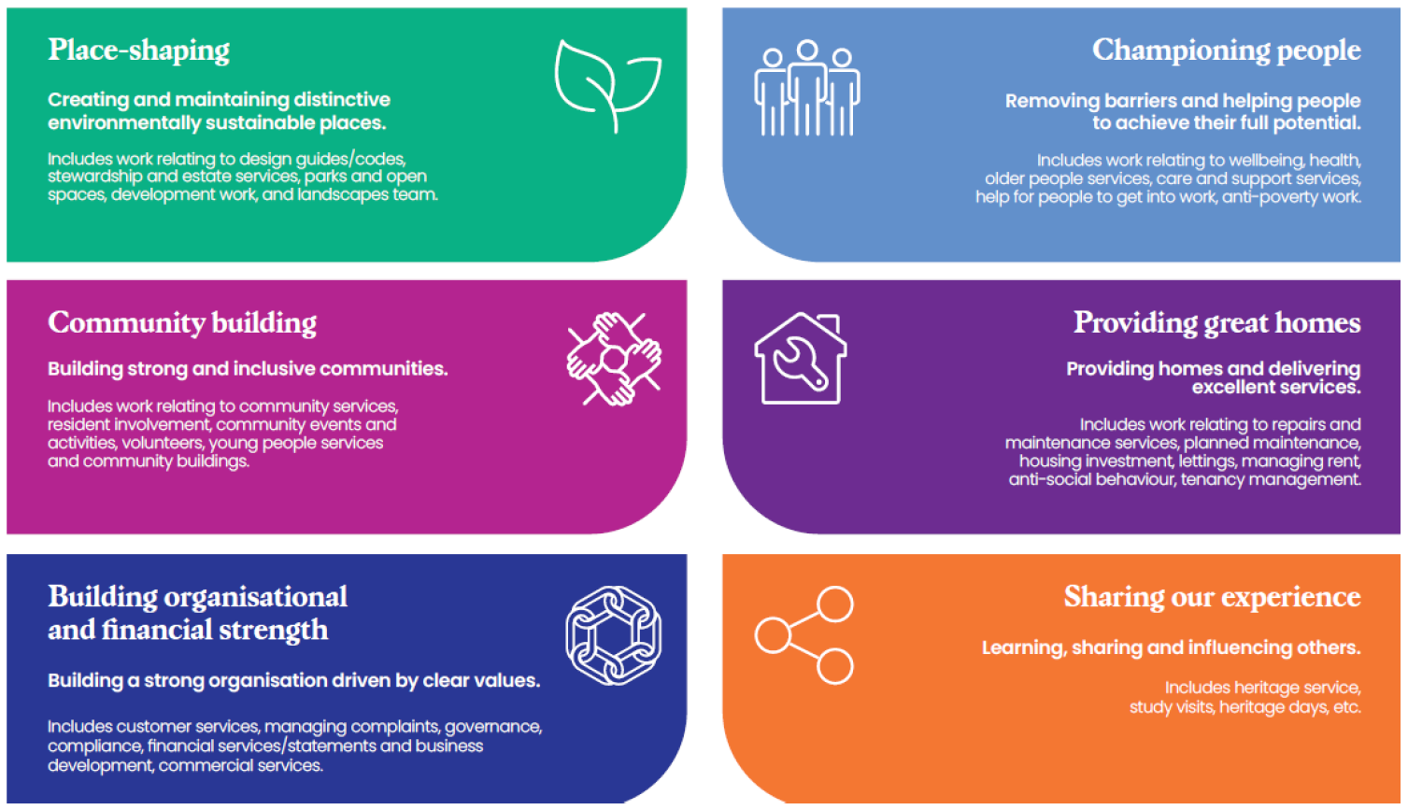

Figure 2 – BVT Company Values

